**Media streaming with IBM cloud video streaming**

|  |  |
| --- | --- |
| **Date** | **04-10-2023** |
| **Team ID** | **675** |
| **Project Name** | **Media streaming with IBM cloud video streaming** |

**Table of Contents**

|  |  |
| --- | --- |
| 1 | Introduction |
| 2 | Problem Statement |
| 3 | Design and Innovation Strategies |
| 3.1 | Content Preparation and Upload |
| 3.2 | Channel Creation and Configuration |
| 3.3 | Content Annotation and Enhancement |
| 3.4 | Live Streaming |
| 3.5 | On-Demand Archiving |
| 3.6 | Engagement and Interaction |
| 3.7 | Analytics and User Feedback |
| 4 | Conclusion |

**1. Introduction**

This document outlines a comprehensive plan for implementing media streaming using IBM Cloud Video Streaming. Streaming media content is a powerful tool for communication, education, and entertainment, and this project aims to leverage IBM's capabilities to enhance the streaming experience.

**2. Problem Statement**

Create a virtual cinema platform using IBM Cloud Video Streaming. Upload and stream your favourite movies and videos on-demand. Share the joy of movie nights with friends and family, no matter where they are located. Elevate the movie-watching experience with seamless streaming and high-quality video playback for a truly immersive cinematic experience!

**3. Design and Innovation Strategies**

In this section, we will delve into the key design and innovation strategies that will shape the success of our media streaming project using IBM Cloud Video Streaming.

**3.1. Content Preparation and Upload**

Innovation: High-Quality Content Preparation

- Ensure media content is of the highest quality and suitable for streaming.

- Support various media formats and resolutions for a diverse audience.

- Implement automated content upload workflows for efficiency.

**3.2. Channel Creation and Configuration**

Innovation: Customized Channel Settings

- Create dedicated streaming channels for different types of content.

- Configure channel settings for optimal streaming quality and security.

- Set access controls to define public or private access to channels.

**3.3. Content Annotation and Enhancement**

Innovation: Interactive Annotations

- Enhance media content with interactive features like text overlays, clickable links, and graphics.

- Implement chapter markers and bookmarks for easy navigation.

- Provide viewers with interactive polls, quizzes, and surveys.

**3.4. Live Streaming**

Innovation: Seamless Live Streaming

- Set up live streaming events with minimal latency for real-time interaction.

- Enable live chat and comments for viewer engagement.

- Implement live closed captioning for accessibility.

**3.5. On-Demand Archiving**

Innovation: Content Accessibility

- Archive live streams for on-demand access by viewers who missed the live event.

- Organize archived content into playlists and categories for easy discovery.

- Implement search functionality for viewers to find specific content.

**3.6. Engagement and Interaction**

Innovation : Real-Time Chat and Discussion

- Implement a real-time chat feature that allows viewers to discuss the movie as they watch, enhancing the social aspect of the platform.

- Enable users to create private watch parties and invite friends for a synchronized movie-watching experience with chat capabilities.

Innovation : User-Generated Playlists

- Empower users to curate and share playlists of their favorite movies and videos, fostering a sense of community and content discovery.

- Allow collaborative playlist creation, where multiple users can contribute to and edit shared playlists for group movie nights.

**3.7. Analytics and User Feedback**

Innovation: Data-Driven Insights

- Collect viewer analytics to understand user behavior and preferences.

- Utilize AI-based sentiment analysis to gauge viewer reactions.

- Gather user feedback through surveys and comments to drive continuous improvement.

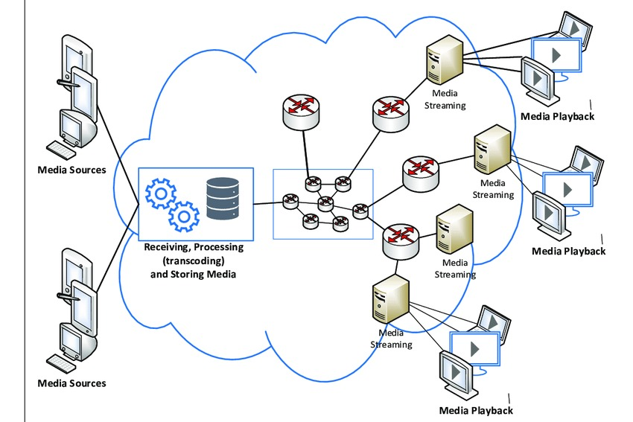

**4. Conclusion**

This media streaming project leverages IBM Cloud Video Streaming to deliver a cutting-edge streaming experience. By focusing on content quality, customization, interactivity, and analytics, we aim to provide viewers with engaging and valuable content. This project not only serves entertainment and education purposes but also contributes to the advancement of media streaming technology. Through a combination of innovation and IBM's powerful tools, we aspire to provide a comprehensive and interactive media streaming solution.